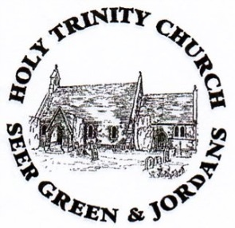
Baptism Policy Statement

- It is the policy of the PCC of Holy Trinity, Seer Green and Jordans to agree to baptise any children of parents who request it and who are willing to make the requisite promises. It is our responsibility as a parish of the Church of England only to baptise children of parents living within the parish or who are regular church attenders and/or are on the Electoral Roll of the parish. If the parents live outside the parish but have a strong link with Holy Trinity they are required first to have the permission of their own parish priest.
- There will be suitable parental preparation for the baptism containing elements of what the Christian faith is; what baptism is and how parents and godparents may enable the children to grow up in the faith of Jesus Christ with a view to confirmation. The baptism preparation is given by the Licensed Lay Minister during the Interregnum period.
- There is the requirement of the godparents that they are baptised, and preferably confirmed, in any denomination that upholds the doctrine of the Trinity. Parents who are not baptised are strongly encouraged to be baptised themselves with appropriate preparation.
- We will also offer a service of Thanksgiving to parents for whom the promises contained in the Baptism Service might cause concerns of conscience or who are from a Christian tradition where baptism is a rite to be entered once the candidate can decide for themselves.
- During the Interregnum period, we will baptise on the second and fourth Sunday of the month within the Communion service, which will be communicated to parents on application.
- Parents will be encouraged to come to church before the baptism takes place.
- For five years after an infant/child is baptised an annual anniversary card will be sent to parents with a renewed invitation to family services and other child-friendly events and services.
- Those adults who wish to be baptised and confirmed will be offered individual preparation in the form of a confirmation course.

LJG/PCC August 2013 (revised for Interregnum period only)

